**Introduction to Python.**

**Python is Open Source Software ie free.**

Downloading the newest version which is 3.8.2.

<https://www.python.org/downloads/release/python-382/>

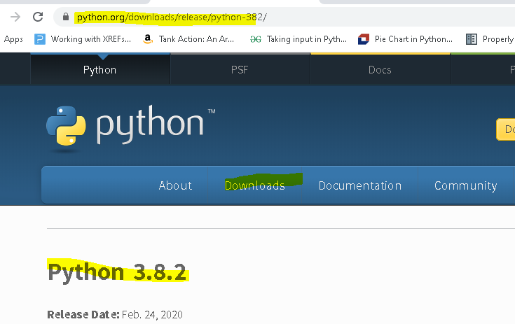

I have Python in the following directory:

C:\Users\wn49s\AppData\Local\Programs\Python\Python38-32

A good way of copying a path is as follows:

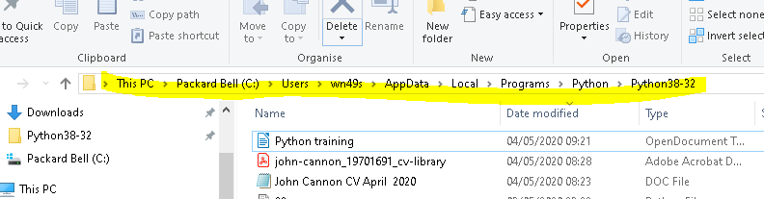

Select as above right click (RC) and copy. This is useful for later in the training because you will have to install numpy, matplotlib and other modules to do anything useful in Python.

Opening Python leads to the Python Shell:

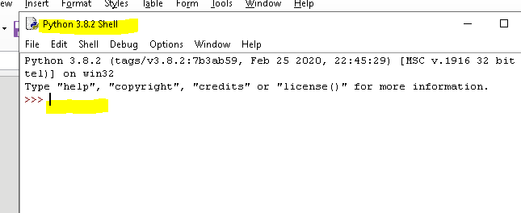

This the GUI for running programs, it’s not for where you write and save them.

You write programs in the Python Integrated Development Environment (IDE). Click on New File in the Python Shell and that opens the IDE:

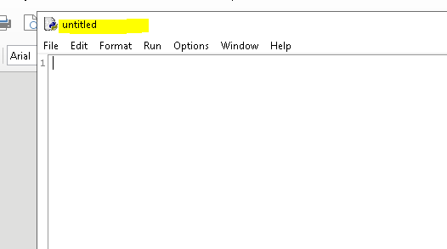

This is a script from the net:

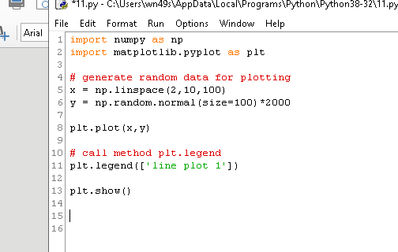

You run it and the following appears in the Python Shell:

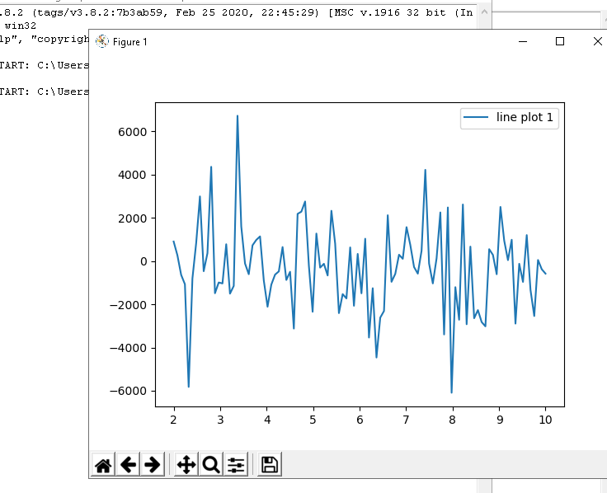

The script uses two modules that have to be installed in the Python directory before it will work, which are numpy and matplotlib.

You install modules using the Windows Shell, not the Python Shell. Open the Windows Shell by typing c at the Windows Search icon and open the Command Prompt, which gives you this:

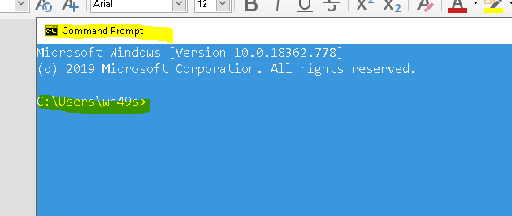

This is the Bill Gates DOS system and it’s where you add modules to Python, but to that first you have to change the directory to the one which contains Python. In my case it is here:

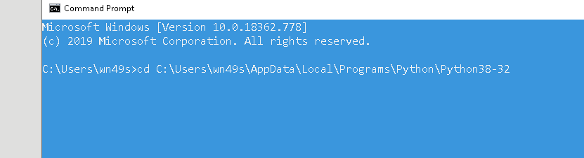

Which I did using the Cut and Paste method described above in File management.

You then press Enter and get this:

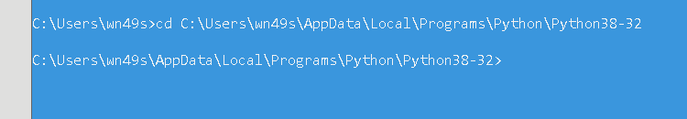

cd is Change Directory in DOS. You change directory as so and then press Enter:

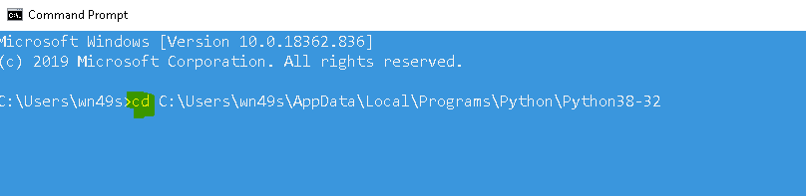

To Paste a file path in DOS you copy the path in File Manager and the RC (right click mouse) in DOS to Paste. Cut and Paste as used in Windows does not work in DOS,remembering that DOS is Windows predecessor as an Operating System, so that’s no surprise.

The hard part is done. You’ve set up Python.

Now we can start loading modules but to do that we need to install PIP. PIP is the  [package installer](https://packaging.python.org/guides/tool-recommendations/) for Python and it needs to be downloaded into the Python Directory.

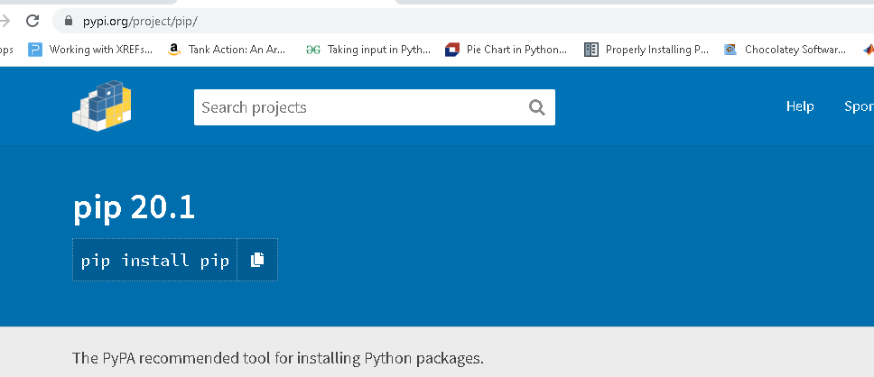

You click on the following:

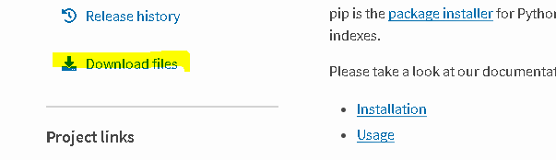

and then you select the following file to download:

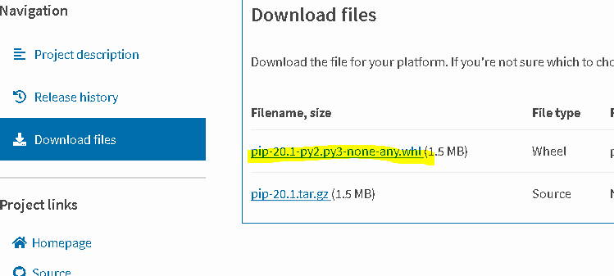

It’s likely that the file has downloaded into the wrong directory so it has to be copied into the directory containing Python. I have set google to download into Python38-32 using the following tab:

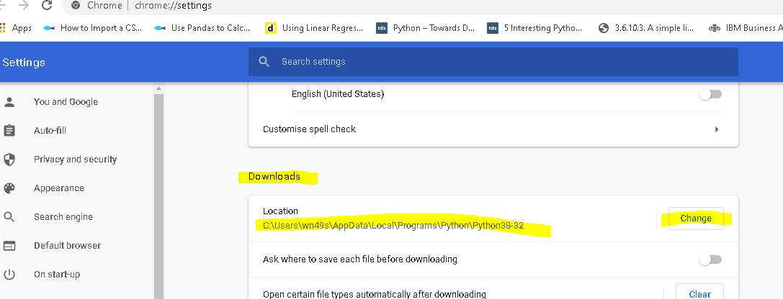

You don’t have to do this, but it will make life a lot easier if you do.

Once it’s there it can be installed using the following:

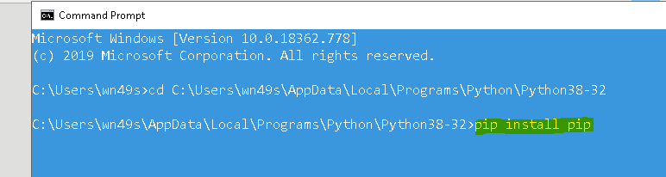

Having installed PIP, you can now install all the modules you want. To run the above script you need numpy, matplotlib. So first of all you need to download to the Python directory. You get them here:

[https://pypi.org/project/numpy/#files](https://pypi.org/project/numpy/" \l "files)

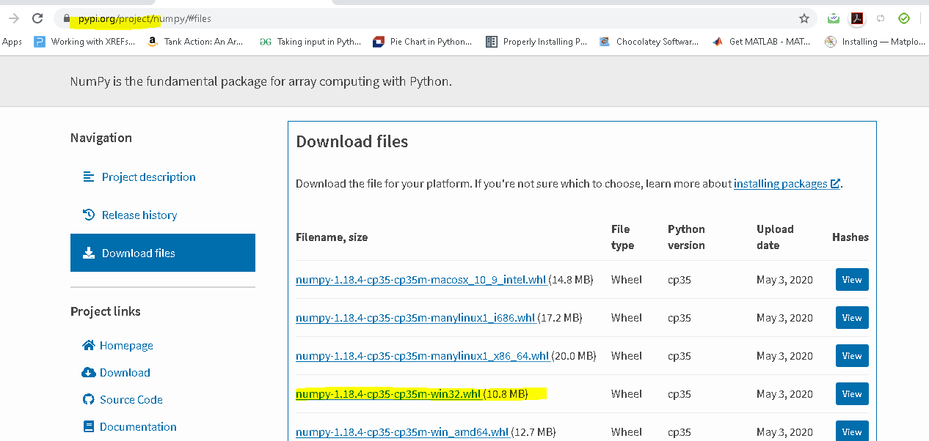

Highlighted above is the Windows version.

You can now install numpy into Python:



You need to do the same with matplotlib. Go to [https://pypi.org/project/matplotlib/#files](https://pypi.org/project/matplotlib/" \l "files)

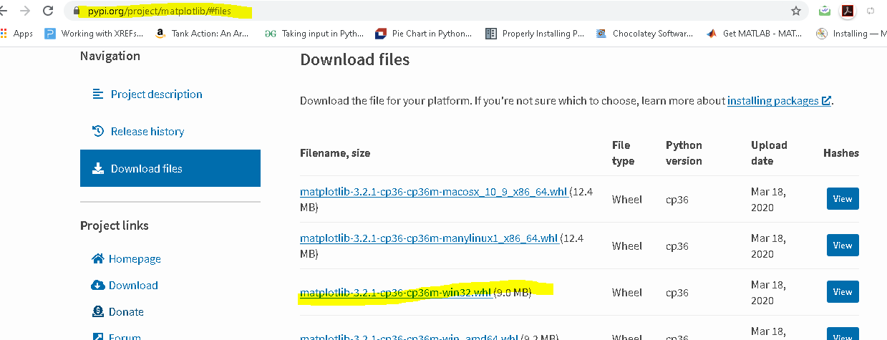

You do the same again as before, but this time with matplotlib:



You are now able to run the above script which is typed here:

import numpy as np

import matplotlib.pyplot as plt

# generate random data for plotting

x = np.linspace(2,10,100)

y = np.random.normal(size=100)*2000

plt.plot(x,y)

# call method plt.legend

plt.legend(['line plot 1'])

plt.show()

It can be cut and pasted into the IDE and run.

With the above knowledge you can now cut and paste code from the Net and create graphs instantly.

This is a good site to start. Just click on a graph type and it will show the code which you can then copy. This is a simple graph:

<https://matplotlib.org/gallery/index.html>

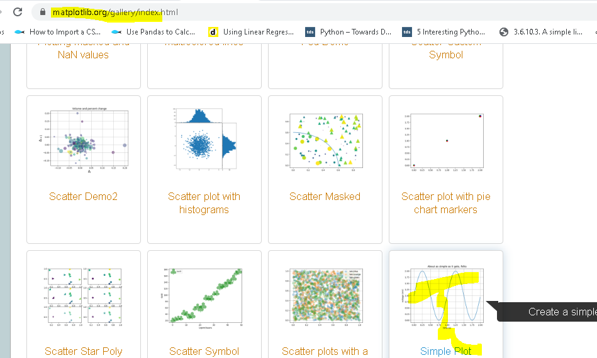

The code is ..

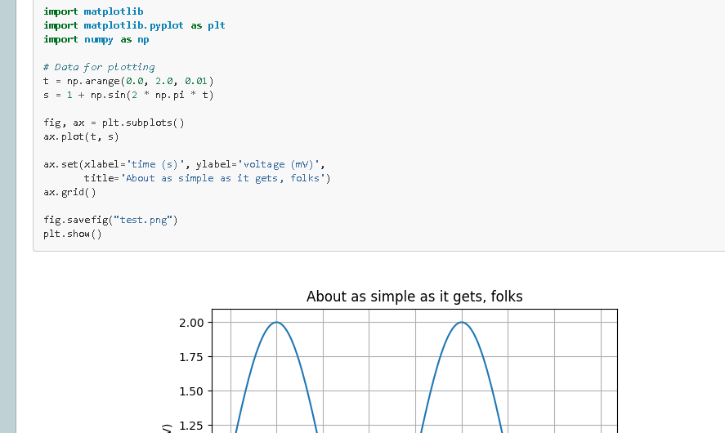

Click on the graph and the code is behind it which you can copy and put into the IDE, save it as a .py file by changing the extension and then run it. It then runs in the Python Shell.

There are other ways of creating graphs from data stored in Excel for example, and I will get onto that next.